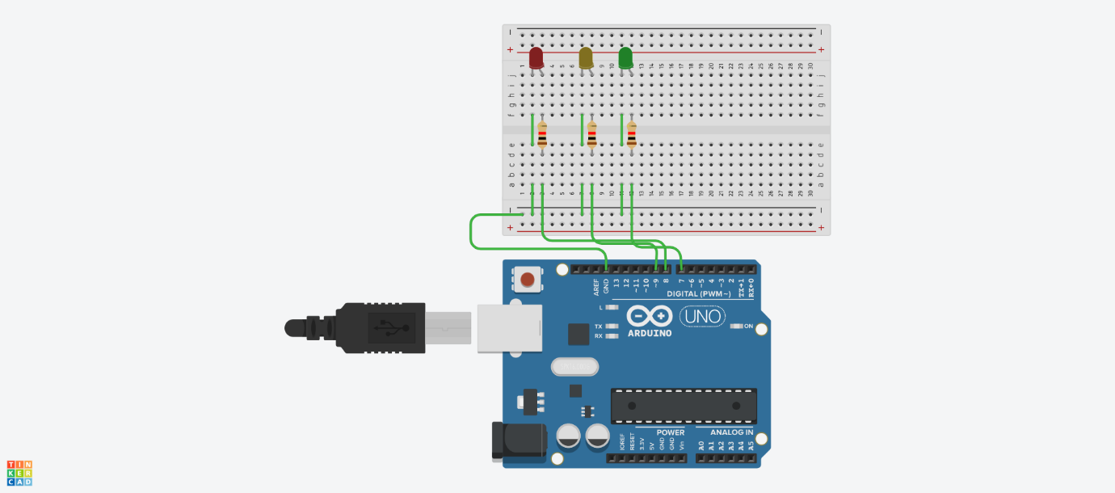

int LED1 = 8,LED2 = 9, LED3 = 7, LED4 = 6, LED5 = 5 , LED6 = 4;
void setup()
{
pinMode(LED1, OUTPUT);
pinMode(LED2, OUTPUT);
pinMode(LED3, OUTPUT);
pinMode(LED4, OUTPUT);
pinMode(LED5, OUTPUT);
pinMode(LED6, OUTPUT);
}

void loop()
{
digitalWrite(LED1, HIGH);
delay(100); // Wait for 100 millisecond(s)
digitalWrite(LED1, LOW);
delay(100); // Wait for 100 millisecond(s)
digitalWrite(LED2, HIGH);
delay(100); // Wait for 100 millisecond(s)
digitalWrite(LED2, LOW);
delay(100); // Wait for 100 millisecond(s)
digitalWrite(LED3, HIGH);
delay(100); // Wait for 100 millisecond(s)
digitalWrite(LED3, LOW);
delay(100); // Wait for 100 millisecond(s)
digitalWrite(LED4, HIGH);
delay(100); // Wait for 100 millisecond(s)
digitalWrite(LED4, LOW);
delay(100); // Wait for 100 millisecond(s)
digitalWrite(LED5, HIGH);
delay(100); // Wait for 100 millisecond(s)
digitalWrite(LED5, LOW);
delay(100); // Wait for 100 millisecond(s)
digitalWrite(LED6, HIGH);
delay(100); // Wait for 100 millisecond(s)
digitalWrite(LED6, LOW);
delay(100); // Wait for 100 millisecond(s)
}

